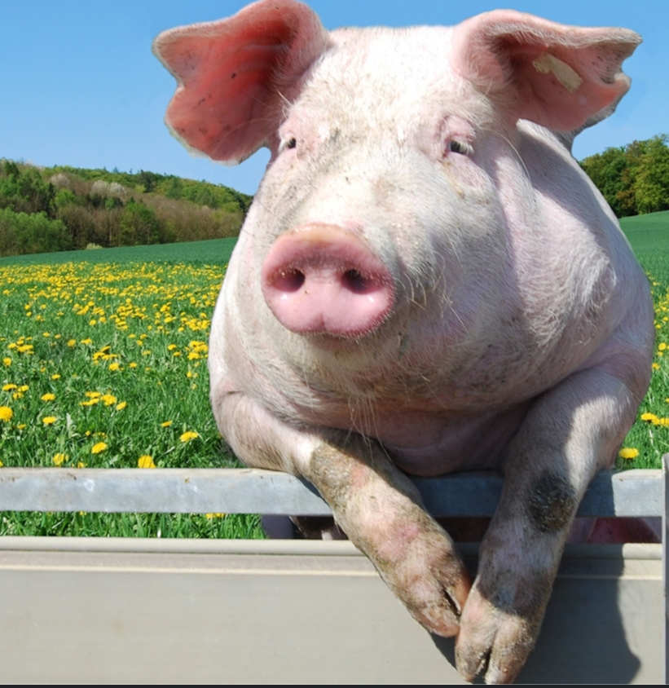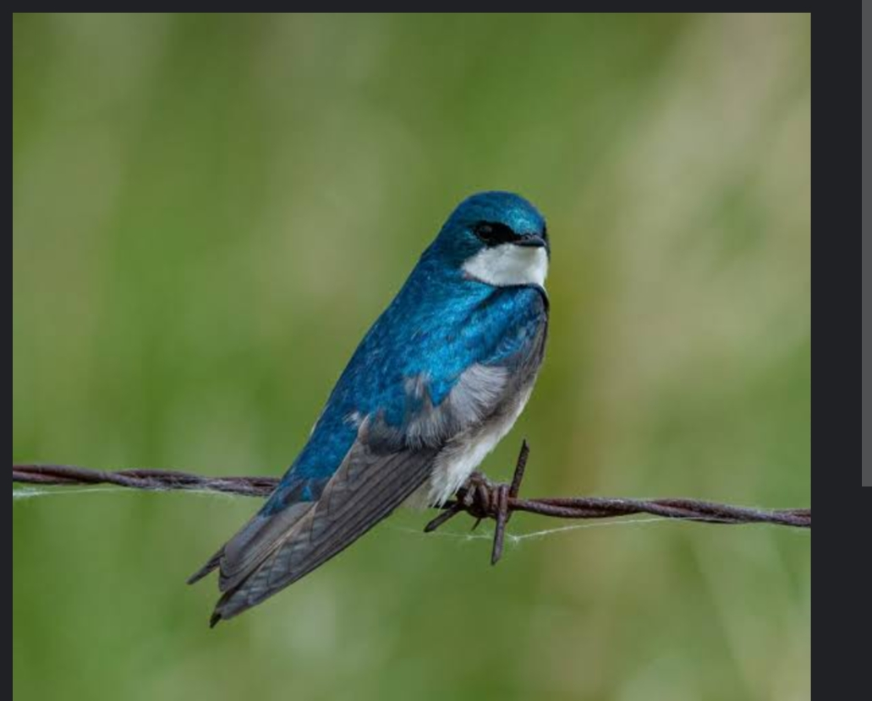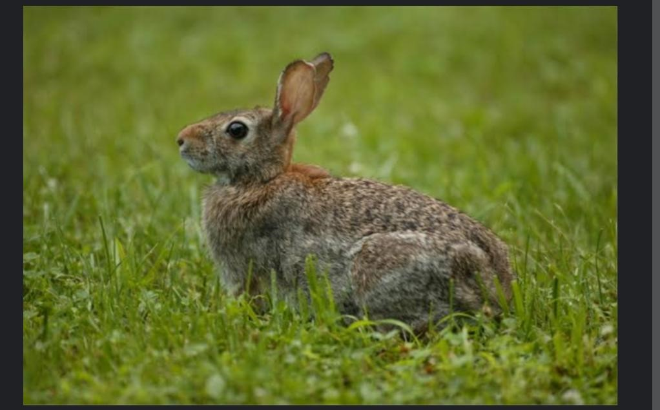

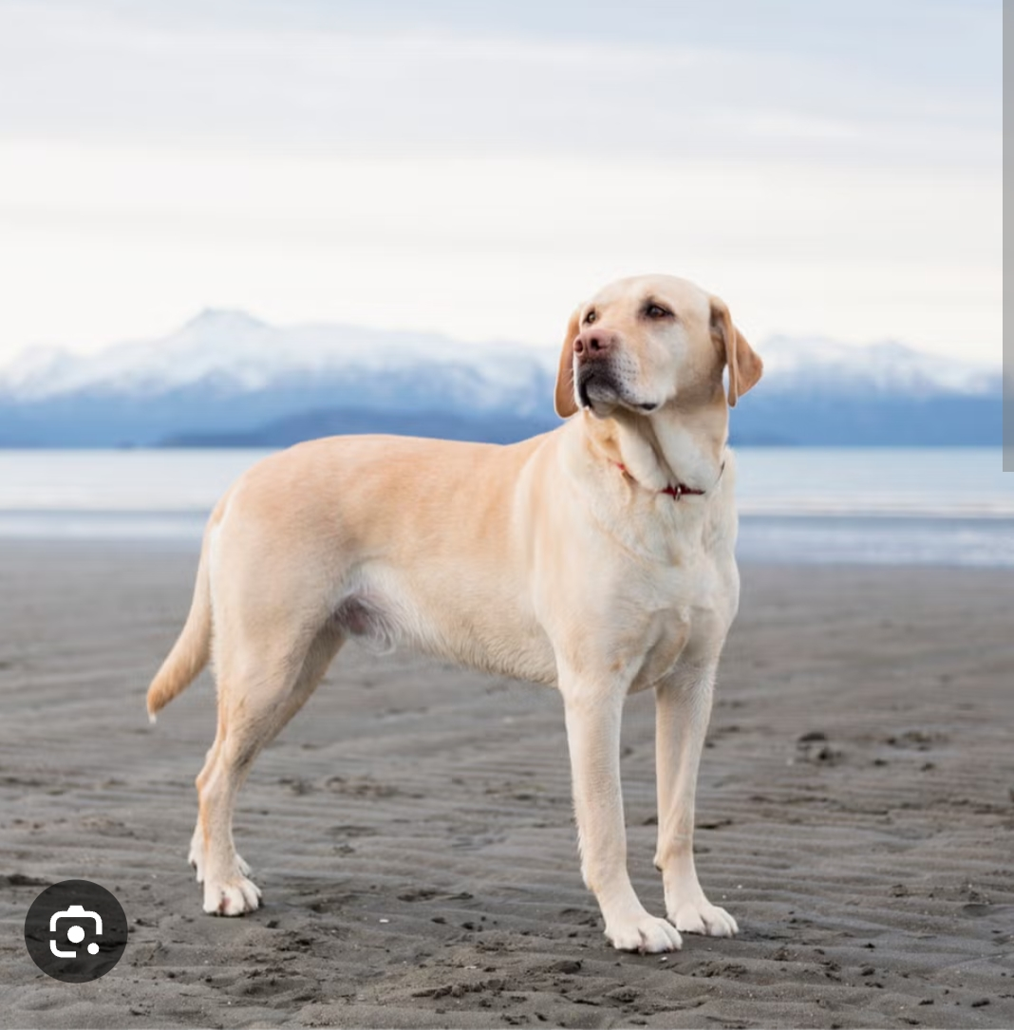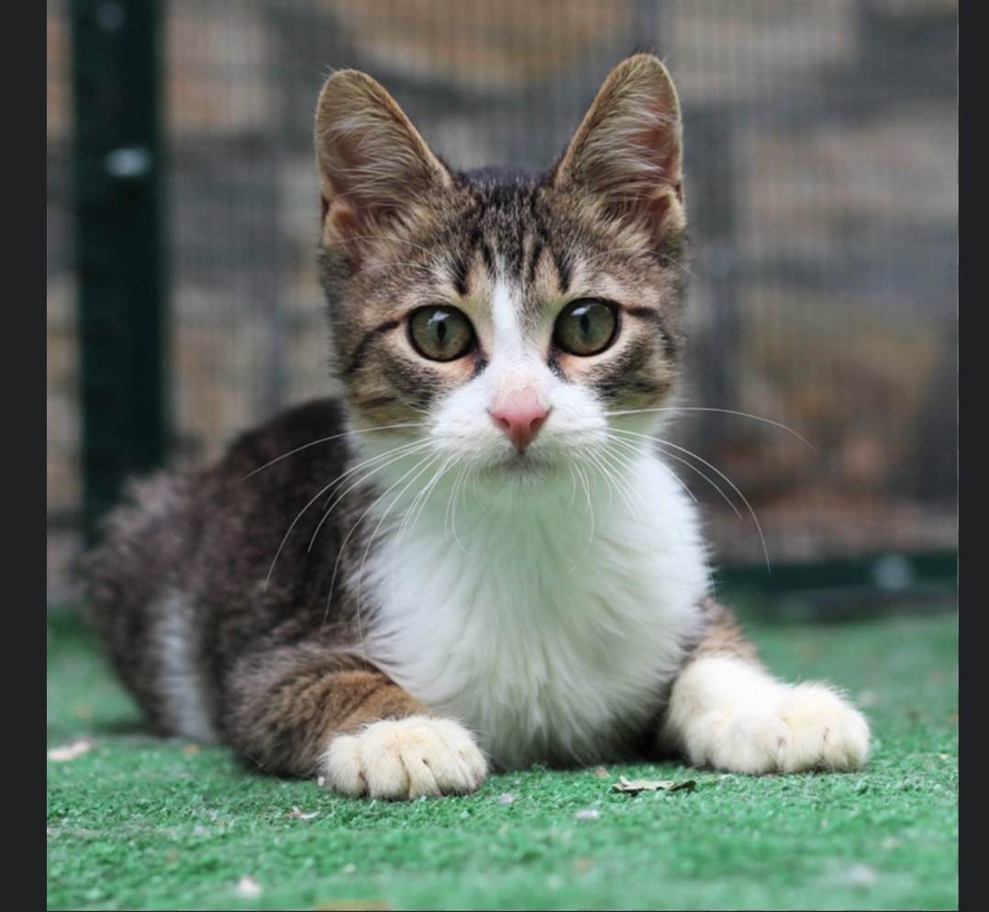

import javax.swing.*;

import java.awt.*;

import java.awt.event.*;

public class RadioButtonDemo extends JFrame implements ActionListener {

JRadioButton birdButton, catButton, dogButton, rabbitButton, pigButton;

JLabel imageLabel;

ButtonGroup group;

public RadioButtonDemo() {

setTitle("RadioButtonDemo");

setSize(400, 300);

setDefaultCloseOperation(JFrame.EXIT_ON_CLOSE);

setLayout(new FlowLayout());

birdButton = new JRadioButton("Bird");

catButton = new JRadioButton("Cat");

dogButton = new JRadioButton("Dog");

rabbitButton = new JRadioButton("Rabbit");

pigButton = new JRadioButton("Pig");

group = new ButtonGroup();

group.add(birdButton);

group.add(catButton);

group.add(dogButton);

group.add(rabbitButton);

group.add(pigButton);

imageLabel = new JLabel();

imageLabel.setPreferredSize(new Dimension(200, 150));

add(birdButton);

add(catButton);

add(dogButton);

add(rabbitButton);

add(pigButton);

add(imageLabel);

birdButton.addActionListener(this);

catButton.addActionListener(this);

dogButton.addActionListener(this);

rabbitButton.addActionListener(this);

pigButton.addActionListener(this);

}

@Override

public void actionPerformed(ActionEvent e) {

String selectedPet = "";

String imagePath = "";

if (e.getSource() == birdButton) {

selectedPet = "Bird";

imagePath = "images/bird.png";

} else if (e.getSource() == catButton) {

selectedPet = "Cat";

imagePath = "images/cat.png";

} else if (e.getSource() == dogButton) {

selectedPet = "Dog";

imagePath = "images/dog.png";

} else if (e.getSource() == rabbitButton) {

selectedPet = "Rabbit";

imagePath = "images/rabbit.png";

} else if (e.getSource() == pigButton) {

selectedPet = "Pig";

imagePath = "images/pig.png";

}

// Display selected pet name

JOptionPane.showMessageDialog(this, "You selected: " + selectedPet);

// Update image

ImageIcon icon = new ImageIcon(imagePath);

imageLabel.setIcon(icon);

}

public static void main(String[] args) {

SwingUtilities.invokeLater(() -> {

new RadioButtonDemo().setVisible(true);

});

}

}